Titulo de Tese

# 1 Daily activity patterns in the Anillaco Tuco-tuco (*Ctenomys sp.*)

## 1.1 Introduction

## 1.2 Methods

### 1.2.1 Study Species

The studied *Ctenomys* population lacks a formal phylogenetic and taxonomic classification but there are some lines of evidence suggesting that the study area is occupied by a single unidentified species (Amaya et al. 2016). In other studies this *Ctenomys*’ species has been referred informally as the Anillaco tuco-tuco (Amaya et al. 2016) and as *Ctenomys aff. knightii* (Tomotani et al. 202) or *Ctenomys cf. knightii* (Valentinuzzi et al. 2009).

### 1.2.2 Study Sitez

Field work was conducted at a site located approximately 5km away from the village of Anillaco, in the province of La Rioja, northwest of Argentina. The study site (-66.95°, -028.80, 1325m; Fig. 1.1) is a relatively undisturbed natural area, with little human disturbance and no artificial light source. The area is surrounded by the Sierra del Velasco moutain range, located within the Monte Desert biome. The Monte Desert is characterized as an open shrubland dominated by Zygophyllaceae (*Larrea cuneifolia* Cav., *Tricomaria usillo*), Fabaceae (*Prosopis torquata*, *Senna aphylla*) and Cactaceae (*Trichocereus* spp, *Tephrocactus* spp) (Abraham et al. 2009; Fracchia et al. 2011; Aranda-Rickert and Fracchia 2011). At the study site a non-extensive survey of the plant community divided in three transects showed a dominance of the families Zygophyllaceae (*Larrea cuneifolia*, *Tricomaria usillo*), Poaceae (*Microchloa indica*, *Aristida mendocina*) and Fabaceae (*Zuccagnia punctata*) (see Appendix). The climate is arid with marked daily cycle and seasonality in temperature and rainfall (see Appendix). The mean annual temperature is 16.6°C (Fracchia et al. 2011), with clear differences in the daily range and between summer and winter months (Abraham et al. 2009). The mean annual rainfall ranges from 145 to 380mm concentrated almost exclusively in the summer months (Fracchia et al. 2011).

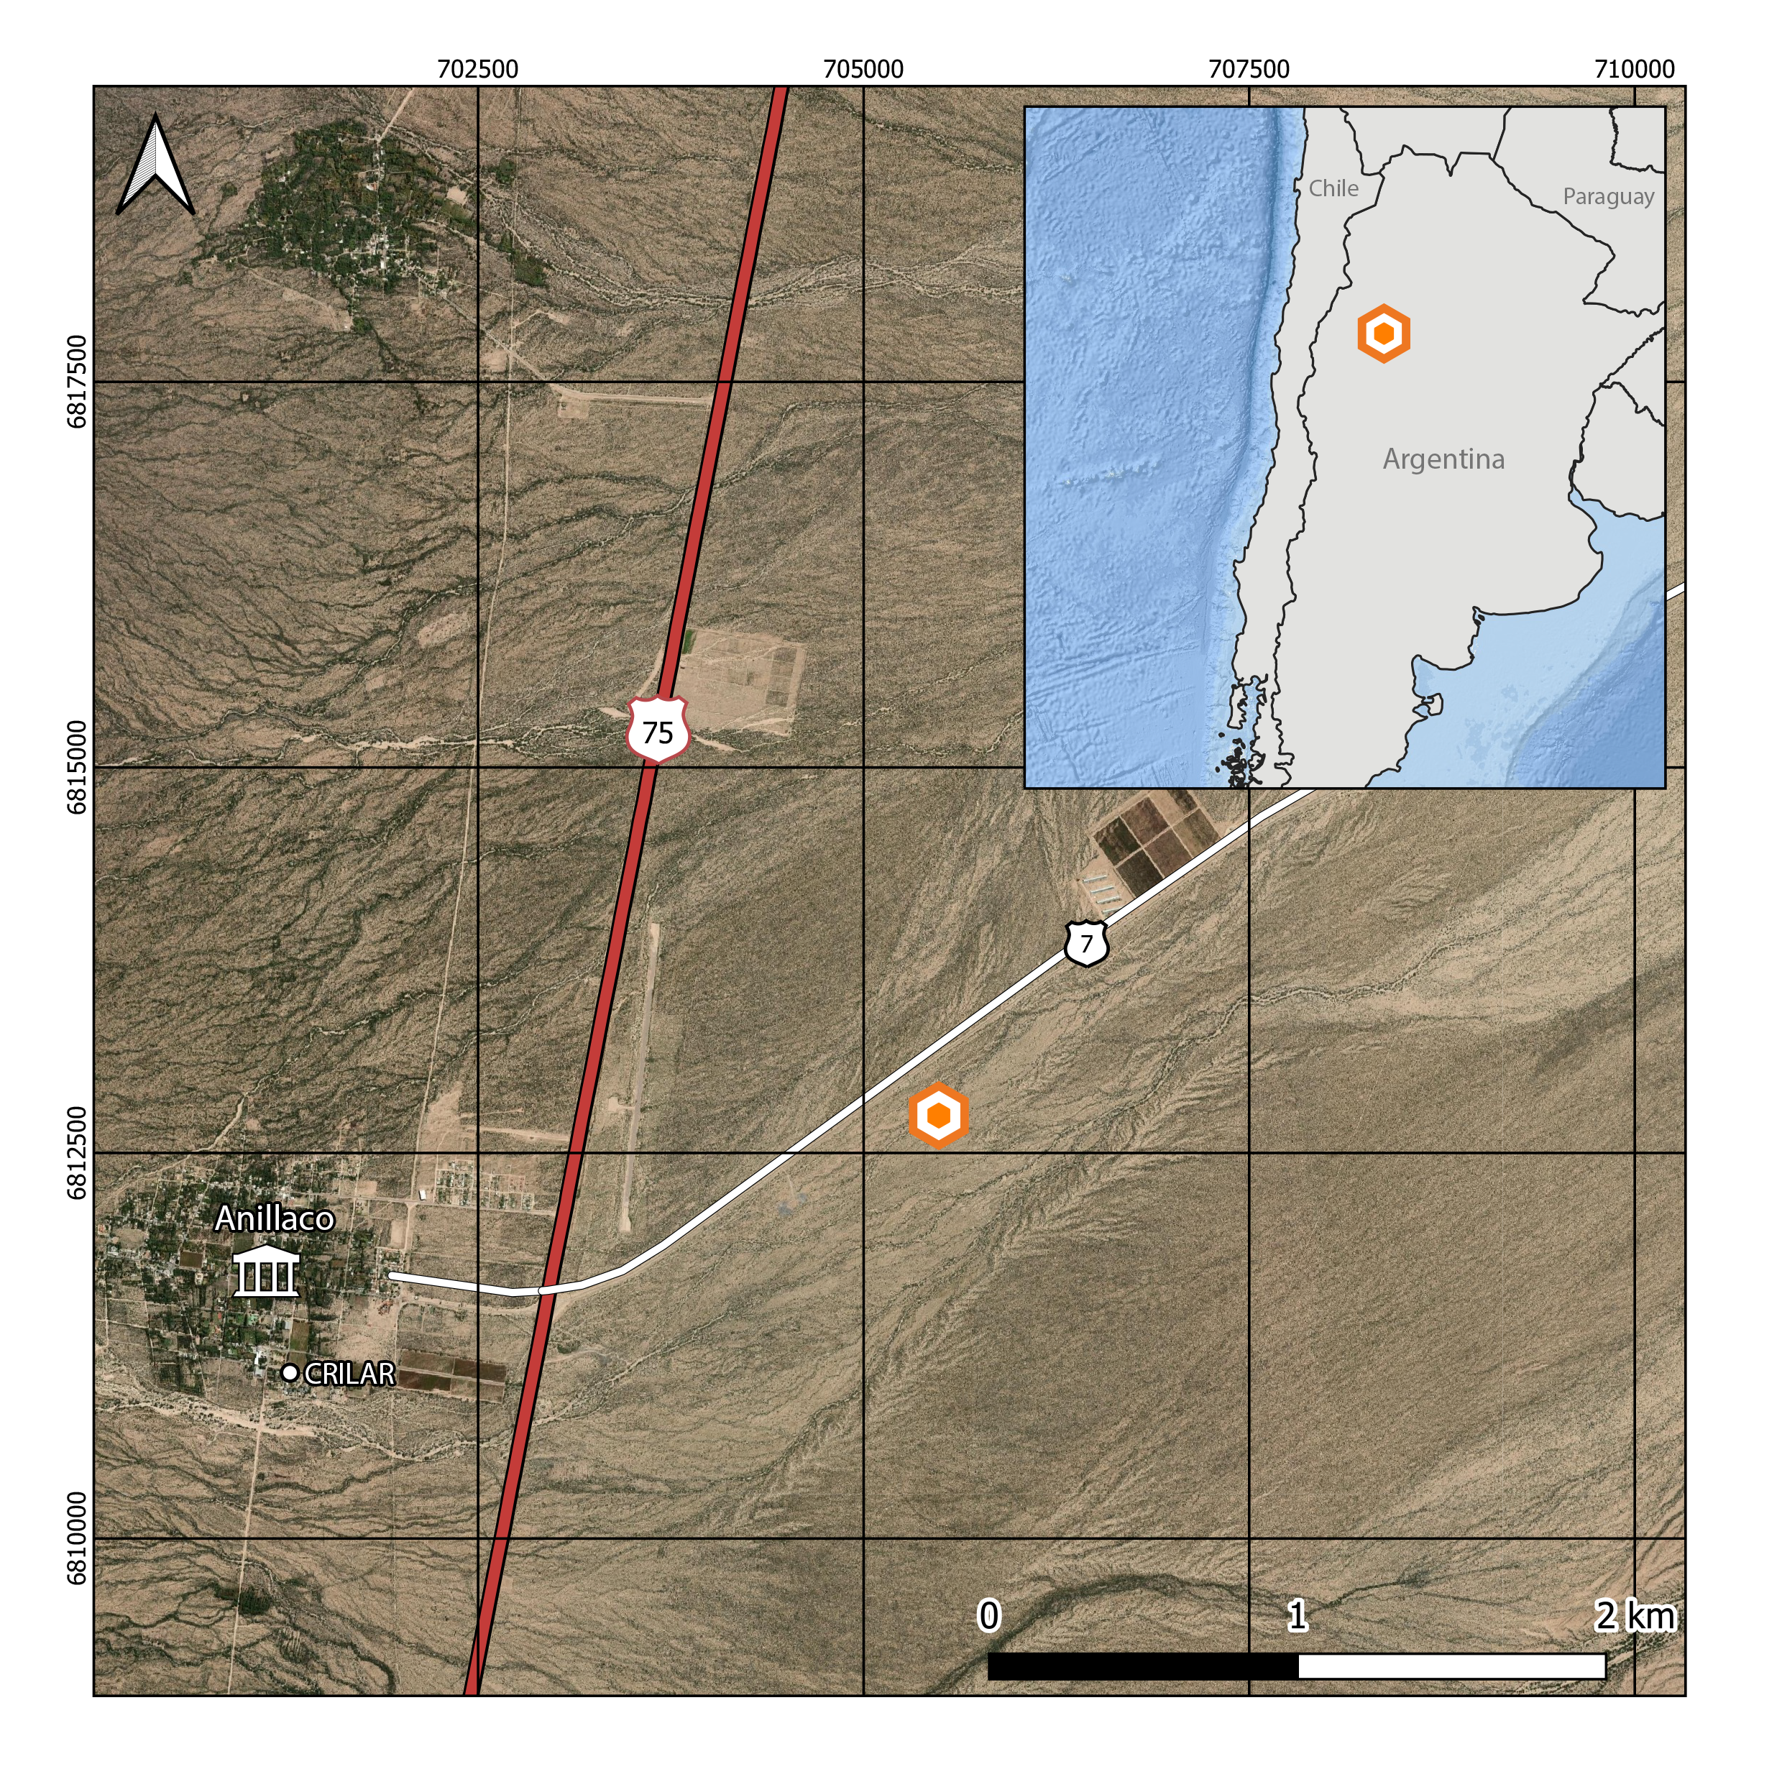

Figure 1.1: Study site location (orange icon) at the Monte Desert, approximately 5km away form the village of Anillaco, northwest of Argentina

### 1.2.3 Animal Capture and Handling

A total of 47 tuco-tucos were captured between March 2019 and March 2020. Out of these, **REF** were part of the present study and we were able to recaptured, and thus collect data, for 22 animals. Trapping was conducted in four different campaigns to the study. Three campaigns were done in 2019 during March-April, July and October. A fourth campaign was done in February 2020. A fifth campaign was planned to occur in May 2020 but had to be canceled due to the COVID outbreak. Tuco-tucos were captured using a custom-made PVC tubing trap (35cm length, 10cm diameter) with a spring-loaded aluminum door at one end and a cul-de-sac at the other. Before setting the trap the study site was scouted for active tuco-tuco’s burrows. Active burrows could be identified by the presence of freshly excavated soil mounds.

Once found, burrows were excavated to open the access to the underground tunnels and a trap was placed horizontally at the burrow’s entrance following the tunnel’s orientation. Traps were placed at all active burrows found at the study site, limited to the number of traps available. Traps were set in the field during the morning and checked every 2 hours, when they were reset if they had been plugged with soil or if they had been activated without any tuco-tuco capture. At dusk they were checked one last time and taken out, the exact time of the trap placement changed accordingly to the seasons.

After capture, adult tucos (>120g) were first lightly anesthetized in order to be carefully examined and receive a collar. We used a clear plastic anesthesia chamber (318.5cm³) with a clip-on lid and a cotton ball inside. The cotton ball inside the chamber received approximately 0.5 mL of isoflurane (*REF*) before transferring the animal from the trap to the chamber. While in the chamber animals were observed for breathing, blinking and loss of righting reflex. Once the tuco-tucos could not right themselves, they were removed from the chamber. Anesthetized animals were weighted (CSseries, OHAUS, ± 1 g precision), sexed, assessed for reproductive status, and marked with a subcutaneous identification PITTag (Passive Integrative Transponder. Allflex, Brasil) and fitted with a collar bearing biologgers (see below).

Animals were released in the same burrow they were originally captured. They were left in the field for 5-18 days before being recaptured for collar recovery. The telemetry transmitter were used to maximize the animals relocation, thus avoiding the loss of the other devices. All animal captures, procedures and animal handling were authorized by the local authorities at *Dirección General de Ambiente y Desarrollo Sustentable – Secretaría de Ambiente del Ministerio de Producción y Desarollo Local* – La Rioja, Argentina (#00501-17). All procedures were also approved by the Ethics Committee at the *Instituto de Biociências* (#308-2018) and *Faculdade de Medicina Veterinária* (#2045300519) of the *Universidade de São Paulo*.

* Ao adicionar numero de animais tbm comentar da dificuldade em recapturar e em alguns casos capturar machos! Legal para futuras referencias. (Talvez nos resultados?)

### 1.2.4 Activity Sensors

Accelerometers (Axy-4, TechnoSmart, Italy) and lightloggers (W65, Migrate Technology, UK) were used to record general motor activity and light exposure, respectively. These biologgers were attached to a collar made of a cable tie inserted through silicon tubing (Jannetti et al. 2019; Williams et al. 2014). A telemetry transmitter was also attached to the collar to detect animal location during recapture (SOM-2011. Wildlife Materials, USA). Out of the 22 captured animals, 13 received a collar containing an accelerometer, a lightlogger and a telemetry transmitter. The remaining 9 animals received a collar containing only a telemetry transmitter and an accelerometer (Table ??). The complete collar setup weighted approximately a total of 6g. Collars without the lightlogger weighted 5.3g. All accelerometers recorded tri-axial acceleration at a 10Hz sampling frequency with a 4G sensitivity. Lightloggers were set to sample light every minute but only recorded the maximum sampled value each 5 minutes.

* foto tuco com colar

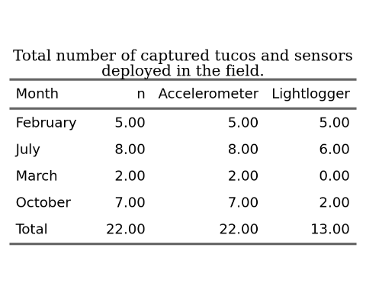

### 1.2.5 Data Processing

A total of 22 complete datasets were obtained from biologgers deployed in the field. Data were recorded onboard of the sensors and later downloaded and converted to raw text files using the software provided by the logger manufacturers. Accelerometer and lightlogger data were read and merged accordingly to date and time of recordings using purposely written R (**colocar citação do software**) scripts. Time of recordings of accelerometers and lightloggers were not synchronized to the minute consequently we had to round the lightlogger recording times to the nearest 5 minutes in order to merge both data streams. We also removed the first and last days of each dataset, corresponding to the days of capturing and recapturing efforts, in order to minimize any effects that the capture, handling or recapture efforts could have in the animal’s behavior.

Acceleration data was used to measure gross motor activity. The tri-axial acceleration data was first converted to one dimensional values using the Vectorial Dynamic Body Acceleration (VeDBA, Qasem et al. 2012). VeDBA is commonly used as a proxy for the animal’s activity level and energy expenditure (REFS). VeDBA was calculated by: (i) Estimating the effect of the gravitational force over the accelerometer, also known as static acceleration. The static acceleration can be estimated by applying a moving average over the raw acceleration data. There is not a consensus over the the number of points to calculate the moving average with, which can be dependent on the study species and device’s recording frequency. In this study, we used a 4-second moving average after following the methodology proposed by (Shepard et al. 2008, see Appendix). (ii) Calculating the acceleration correspondent to the animal’s movement, also know as Dynamic Body Acceleration (DBA). The DBA was calculated by subtracting the static acceleration from the raw data. (iii) Lastly, we calculate the VeDBA by the vectorial sum of the DBA over the device’s axes.

$$VeDBA=\sqrt{Xd^{2}+Yd^{2}+Zd^{2}}$$

Once VeDBA was calculated, the 1Hz acceleration data was downsampled by taking the median over a 1-minute non-overlapping sliding window. All VeDBA datapoints were classified as occuring during the daytime or nighttime based on the daylength of recording dates. Daylength was calculated using the *maptools* package in R (Bivand and Lewin-Koh 2020), which uses the National Oceanic and Atmospheric Administration (NOAA) equations for estimating Twilight times. We used Civil Twilight times, defined as the times in which the center of the sun is 6° below the horizon, as thresholds to calculate daylength and classify datapoints as occuring during the day or nighttime. Daylength change along the year can be seen in the Appendix (REF da figura).

Light exposure data was used to further classify data points as above or below ground during the daytime. The threshold for considering a data point as being aboveground was 2 lux, consistent with what has been done in (Jannetti et al. 2019). All data processing and statistical analysis were conducted in R v4.0.2 (R Core Team 2020) unless stated otherwise.

### 1.2.6 Hidden Markov Models

Behavioral States were inferred using Hidden Markov Models (HMMs). HMMs are type of dependent mixture models where the components of the mixture are selected by an underlying Markov Process (inserir referência). HMMs are composed of two time series: the observable *state-dependent process* ($X_{t}$) and an underying, or hidden, *state process* ($S_{t}$). The *state process* is also what drives the observations and what we are interested in estimating. The underlying *state process* follows the Markov Property and take temporal dependency into account. The Markov property denotes that a state $S_{t}$ depends only on the previous state $S_{t−1}$. In the case of accelerometer and animal movement studies the states are representations of the animals’ behavior and can take on finite number ($N$) of possible values. The number of states can be chosen *a priori* or based on model selection (Pohle et al. 2017). The changes probabilities between states are also part of the of HMM formulation, summarized by a Transition Probability Matrix that gives the probability of transitioning from the current state to a possible future state

In the basic HMM formulation the observable *state-dependent process* comes from a mixture of $N$ distributions, one for each state. These distributions come from a common family (e.g. Normal, Weibull or Gamma) and each one have their own set of parameter values. The active distribution is determined by the state the system is in at a given time $t$. The observations therefore are a realization from one of these distributions. The distribution parameters, state transition probabilities and other model parameters can be estimated by numerical maximization of the Likelihood (Zucchini, Iain MacDonald, and Roland Langrock 2016). With the model parameters in hand, the most probable state sequence can be found by the Viterbi algorithm (Brett T. McClintock et al. 2020; Zucchini, Iain MacDonald, and Roland Langrock 2016).

* vantagem do HMM para modelar series temporais

### 1.2.7 Model Formulation and State Classification

In our models we have chosen VeDBA as our activity metric from which we want to infer the possible state sequences. We determined *a priori* that the hidden *state-process* could assume three different states ($N=3$). This decision was made based on our research question, in the VeDBA distributions (see Appendix; Exploratory Data Analysis) and in the biological interpretability of the states. It is important to note that states do not correspond directly to specific behaviors (e.g. feeding, foraging or digging) but can be assumed to roughly correspond to behavioral modes (e.g. activity levels) that can encompass a range of different behaviors (Leos-Barajas et al. 2017; Papastamatiou et al. 2018). We labelled the states as roughly corresponding to “Rest,”“Medium Intensity Activity” and “High Intensity Activity.”

HMMs can be fitted individually (e.g. van de Kerk et al. 2015) or to a pool of animals (Langrock et al. 2012). The models can also include covariate effects that modify either the *state-dependent* distribution parameters or the transition probabilities (Patterson et al. 2009; Langrock et al. 2012). We fitted a 3-state HMM to the 1-minute downsampled VeDBA data using a ‘complete pooling’ approach. Using this approach, the *state-dependent* distribution parameters are common to all animals. This means that we assume that individuals are independent, and behaviors are the same to all individuals and across the year. However, given that the season/month of the year seems to be an important feature influencing the VeDBA distribution (see Appendix; Exploratory Data Analysis) we included season as a covariate in the *state process*. Therefore, we let the probability of changing from one state to another vary in relation to the season/month of the year, assuming that animals have the same **repertoire** of behaviors. We also fitted an empty model, with no covariate effects, and used Akaike’s Information Criteria (AIC) to select the model with best fit to the data (Burnham, Anderson, and Burnham 2002).

Models were fitted using the momentuHMM package in R (Brett T. McClintock and Michelot 2021). We used the gamma distribution, parametrized with mean and standard deviation, to model VeDBA. The gamma distribution is a flexible distribution, usually used in movement studies (REFS), that accommodates positive right-skewed data. Appropriate starting values for likelihood maximization of the model’s parameters were found by following procedures suggested by Michelot and Langrock (2019). Season was included as a categorical variable, its influence over the transition probabilities was summarized using stationary probabilities plots (Leos-Barajas et al. 2017). The most probable state sequence was decoded using the Viterbi algorhithm (Zucchini, Iain MacDonald, and Roland Langrock 2016). The decoded sequence was then used to conducted othet *post-hoc* analysis of rhythmicity and diurnality. We checked model assumptions and goodness of fit by visual inspection of the pseudo-residuals (Zucchini, Iain MacDonald, and Roland Langrock 2016).

* michelot 2017 - Estimation and simulation of foraging trips in land-based marine predators. Ecology 98, 1932–1944. [doi.org/10.1002/ecy.1880](https://doi.org/10.1002/ecy.1880)

### 1.2.8 Rhythmicity and Diurnality Index

## 1.3 Results

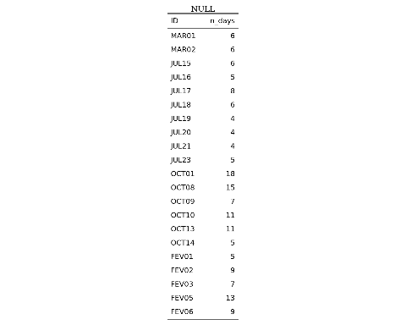

* lista de animais
* lista de quanto tempo cada animal teve de registro
* tabela parametros estimados
* residuos, model fit

## 1.4 Discussion

* Optamos pelo tipo de modelos mais simples com outras a analises a posteriori. Existem outros métodos interessantes Patterson 2009. Extensions to out model could include (…)

# 2 Anillaco’s Plant Community

Following methods similar to REFaranda-rickertExtrafloralNectarFuels2014 a non-extensive survey of the plant community at the study site was done in May 2019. Three perpendicular 50m transects were defined near the study site (COORDINATES). A point-intercept method was used to record plant species present in the transects, species right below the sampling points were registered in the data. Sampling points were defined every 1m along the 50m transects. Plant species were identified in the field by a Botanist, except for a few members of the Poaceae family.

The results for the plant survey is in line with what has been described in the literature for the region [REFabrahamOverviewGeographyMonte2009; REFaranda-rickertExtrafloralNectarFuels2014; REFfracchiaDispersalArbuscularMycorrhizal2011]. The results show a dominance of Zygolhyllaceae, Poaceae and Fabaceae families. The relative frequency of plant families and species recorded in the area are shown in the graphs below (Fig. 2.1).

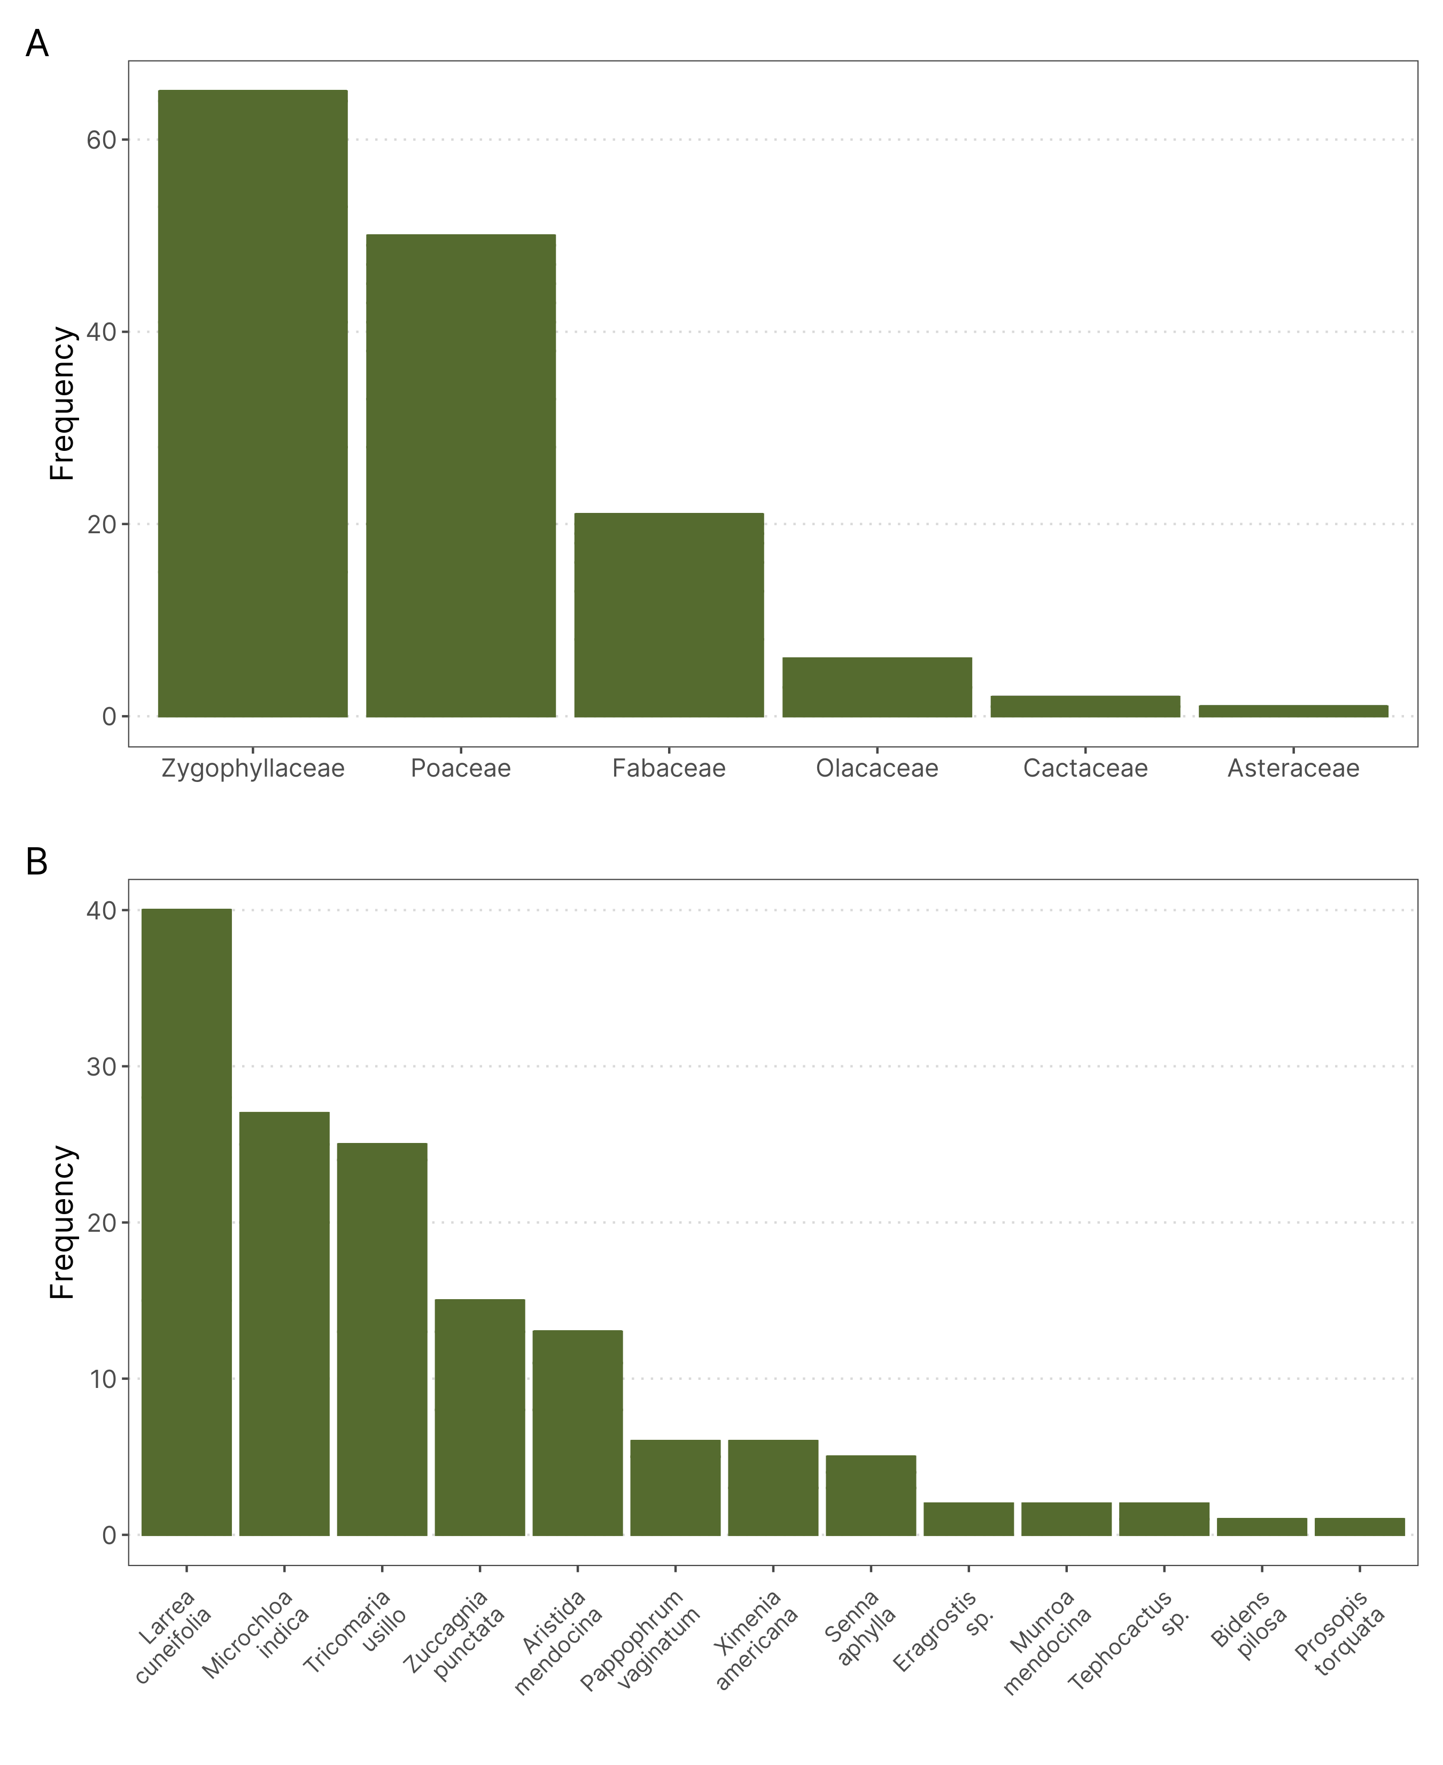

Figure 2.1: Relative frequency of plants family (A) and species (B) in three transects near the Study Site. The plant community is dominated by members of the Zygolhyllaceae, Poaceae and Fabaceae families and is in accordance with what has been described in the literature. (n = 145)

# 3 Anillaco’s Weather

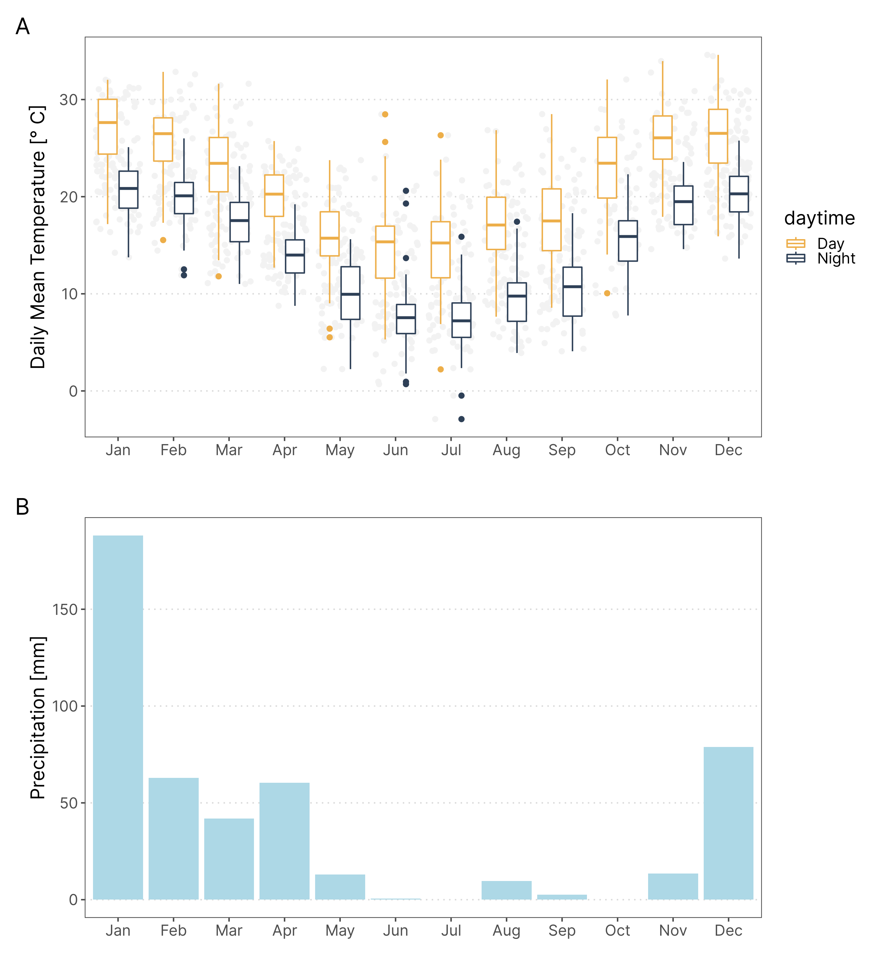

Figure 3.1: Temperature and Rainfall yearly trends in Anillaco, Argentina. Data was collected in the years 2017 and 2019 from a weather Station (Vantage Pro 2, Davis Instuments. USA.) maintened in CRILAR, aproximately 5km away from the study site.

# 4 Anillaco’s Yearly Daylength Changes

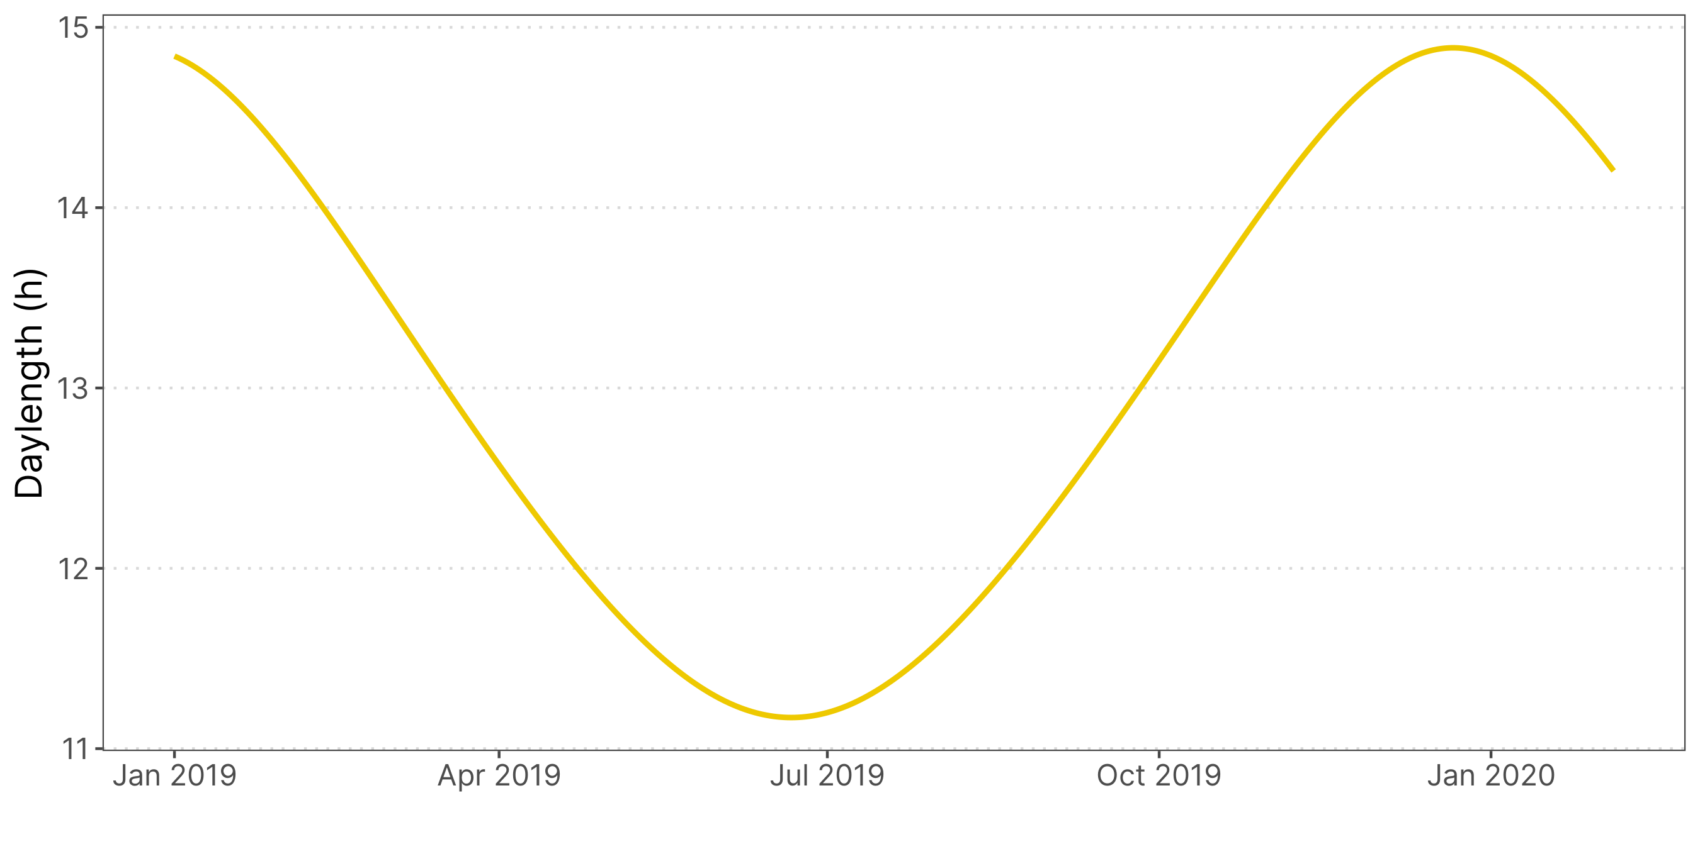

Figure 4.1: Changes in daytime changes across the year in Anillaco, La Rioja. Maximum duration of daytime, during summer, is 14 hours and 53 minutes. Mininum duration of daytime, during winter, is 11 hours and 10 minutes.

# 5 Static Acceleration Smooth window Assessment

Using

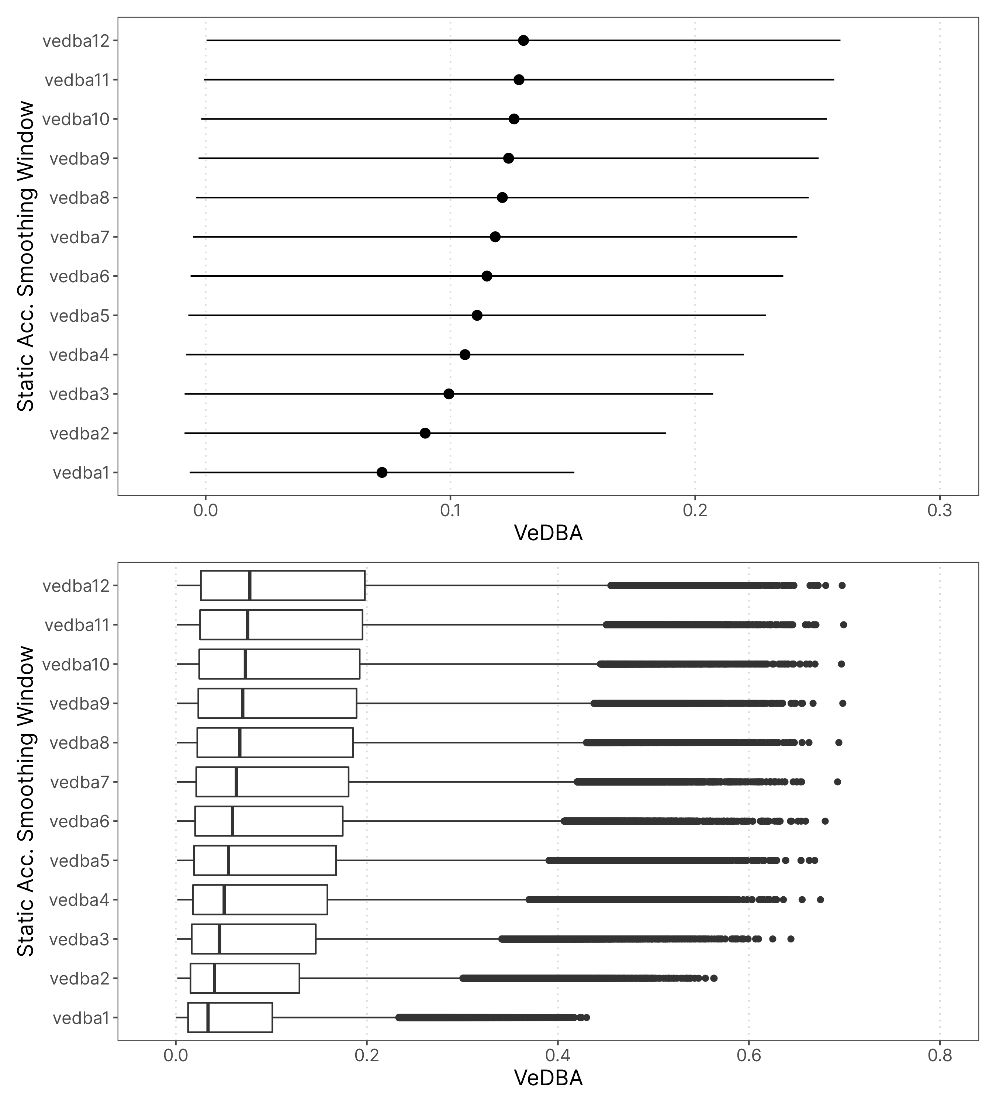

# 6 Exploratory VeDBA data Analysis

## 6.1 Data Pre-processing

Os dados de acelerômetro são coletados em 10Hz. Para transformarmos os dados da aceleração de cada eixo em um índice de atividade calculamos o VeDBA. Esse índice é a soma vetorial dos valores de aceleração dos valores de cada eixo descontado o valor da gravidade. Depois de calculado o VeDBA vamos resumir os dado para tornar as análises mais convenientes computacionalmente e também melhorar a visualização desses dados. Os dados de VeDBA foram resumidos a cada um minuto usando-se a mediana dessa janela de tempo, o que corresponde a uma mediana móvel sem sobreposição a cada 600 amostras. A maneira que podemos *interpretar esses dados* é que cada amostra na verdade representa o valor de VeDBA que o animal teve por pelo menos 30s consecutivos. Ou seja, caso uma amostra tenha valor de 0.4 de VeDBA podemos afirmar que naquele minuto o animal se manteve com um VeDBA maior ou igual à 0.4 durante 30 segundos consecutivos. Isso talvez tenha mais importância depois que classificarmos as amostras usando o HMM.

Os dados de exposição à luz são amostrados a cada 1 minutos mas só registram a amostra com maior valor a cada 5 minutos. Para esses dados o que penso ser a melhor saída é estabelecer um limiar e considerar que qualquer valor maior que esse limiar é um episódio de exposição à luz. Para isso sigo usando o limiar de 2 lux. Importante também pensarmos que temos dados de acelerômetro e lightlogger que são desiguais temporalmente e talvez seja necessário nos atentarmos pra isso quando sobrepusermos esses dados.

## 6.2 Time Series Plot

Primeiro uma verificada geral nos dados em formato de série temporal. Os gráficos mostram apenas os 4 primeiros dias de registro de cada animal.

Não é possível ver muita diferença entre os animais então nas séries temporais então estão plotados apenas 4 animais. É interessante que em alguns animais já é possível ver que oo pontos parecem estar mais ou menos organizados em três regiões distintas na vertical.

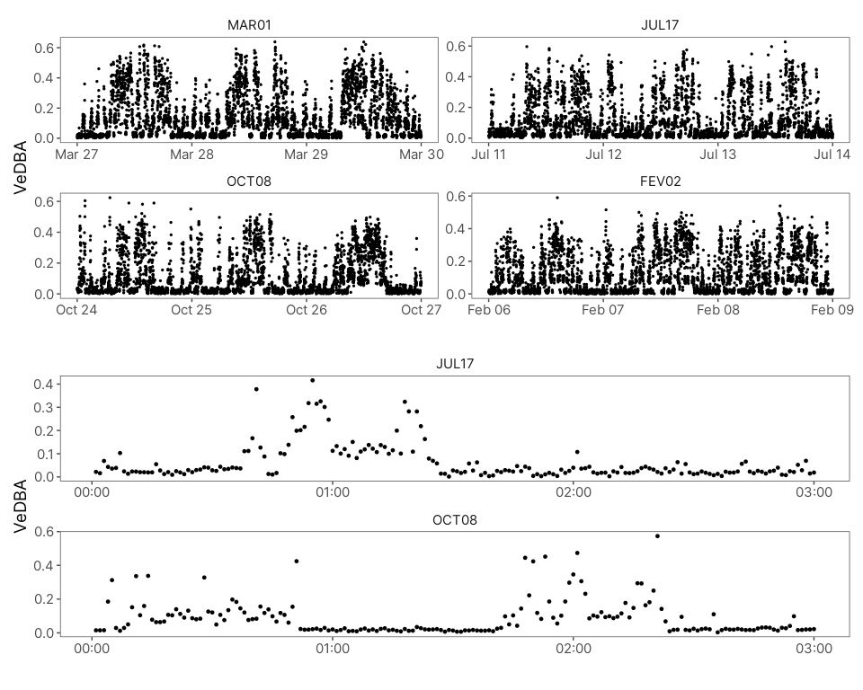

## 6.3 Actogramas

Os actogramas estão divididos por animais, com o sexo no topo direito. Os dados de acelerômetro estão em preto, sem nenhum limiar aplicado aos gráficos. Os dados de exposição à luz estão em laranja, todos registros maiores do que 2 lux são considerados como uma saída e plotados como barras nos gráficos.

O segundo conjunto de actogramas estão num formato de heatmap. Esses actogramas possuem apenas os dados de atividade e foram plotados apenas para ver se observaíamos melhor algum padrão em relação aos actogramas de barras.

O que é possível observar nos actogramas, e que não é muita surpresa, é que parece realmente existir algum ritmo circadiano nos animais de campo. Esse ritmo é mais marcado em alguns animais do que em outros, independente da época de captura, como por exemplo entre os animais MAR01 e MAR02.

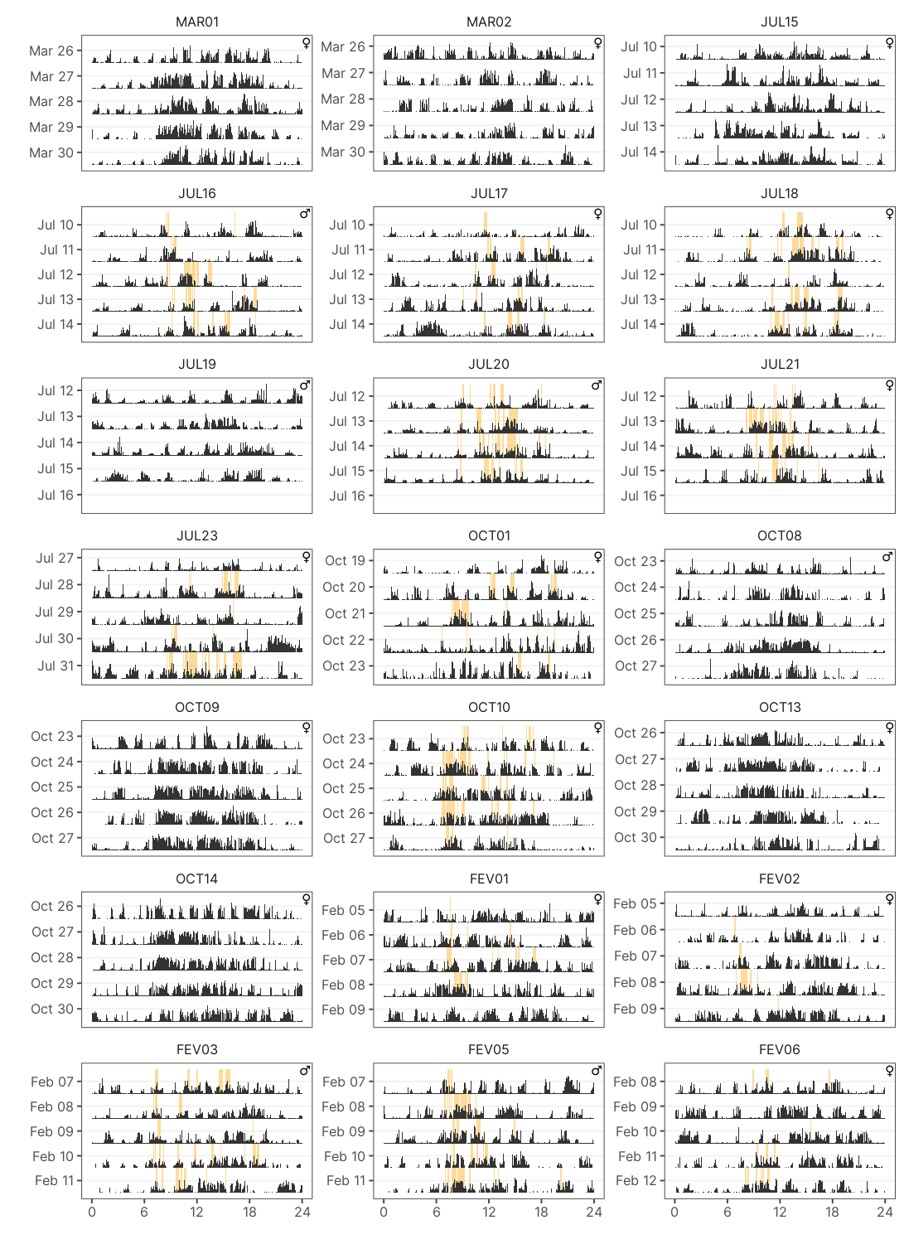

## 6.4 Histogramas e Gráficos de Densidade

Antes de seguir para outras análises vamos observar as distribuições dos dados de acelerômetros para ver se há muita heterogeneidade entre os animais. Os dados de atividade para esses gráficos foram limitados à 4 dias por animal, assim o número de amostras por animal é o mesmo.

As distribuições de VeDBA parecem ter um range muito próximo de valores. Ou seja, parece não haver animais que possuam uma atividade muito mais intensa do que outros, o que também pode ser visto na tabela abaixo. Porém, o formato da distribuição muda entre alguns animais, principalmente entre estações. Por exemplo, os animais capturados em outubro parecem ter maior número de amostras com valores mais à direita da distribuição, entre 0.2 e 0.5. Alguns animais capturados em Fevereiro parecem continuar com essa tendência. Em julho, porém, os animais parecem ter uma distribuição com maior concentração em valores mais centrais, entre 0.05 e 0.2. Essas mesmas tendências também podem ser observadas de uma forma mais compacta no gráficos de densidade por animal.

Então, os animais, apesar de terem distribuição de VeDBA que não distoam muito uns dos outros no seu range, parecem passar tempos diferentes em tipos de diferentes de comportamentos.

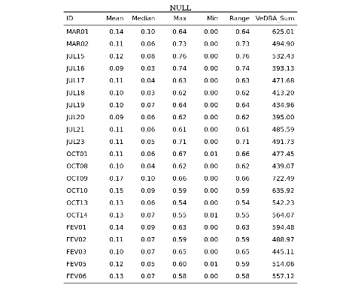

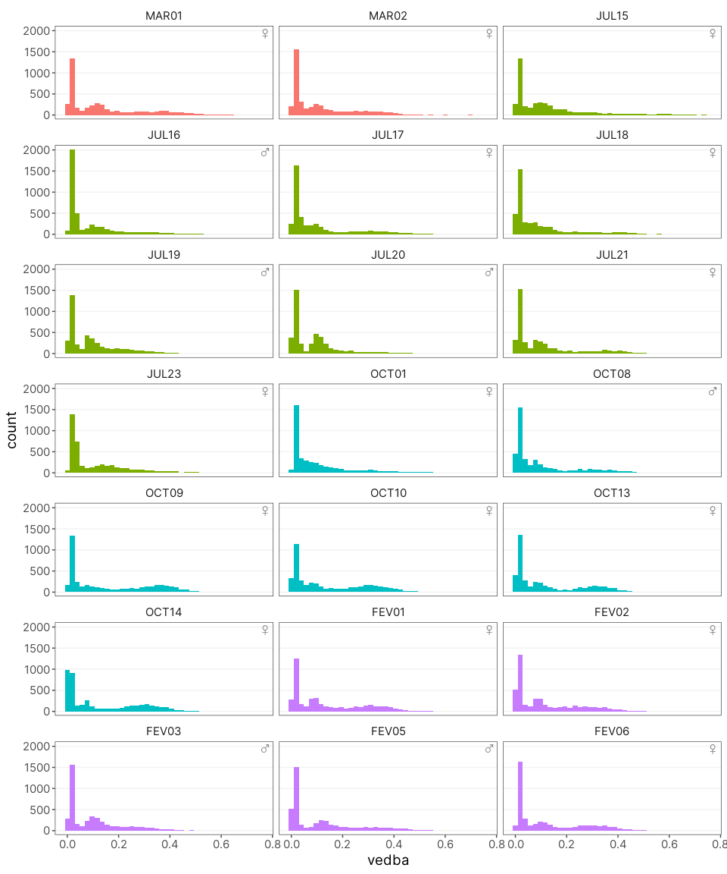

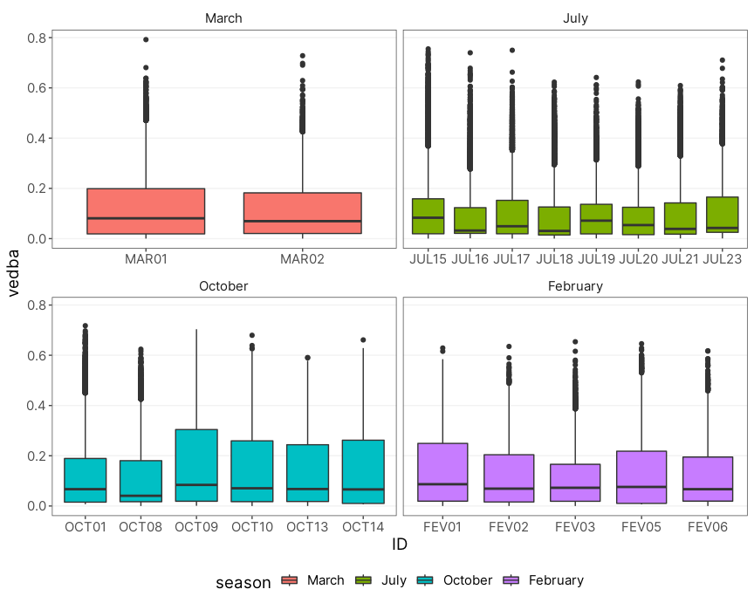

Figure 6.2: Ridge plot mostrando a densidade da distribuição dos valores de VeDBA divididos por animal. As cores representam os meses em que os animais foram capturados.

## 6.5 Padrões Médios de Atividade por Animal

Para terminar, é interessante ver como é o “ritmo médio” ao longo de todo tempo de registro dos animais. Acho que esse gráfico é especialmente interessante para pessoas fora da cronobiologia, já que é bem mais intuitivo do que os actogramas.

Nesses primeiro gráfico foi plotado a média por hora dos valores de VeDBA de cada animal.

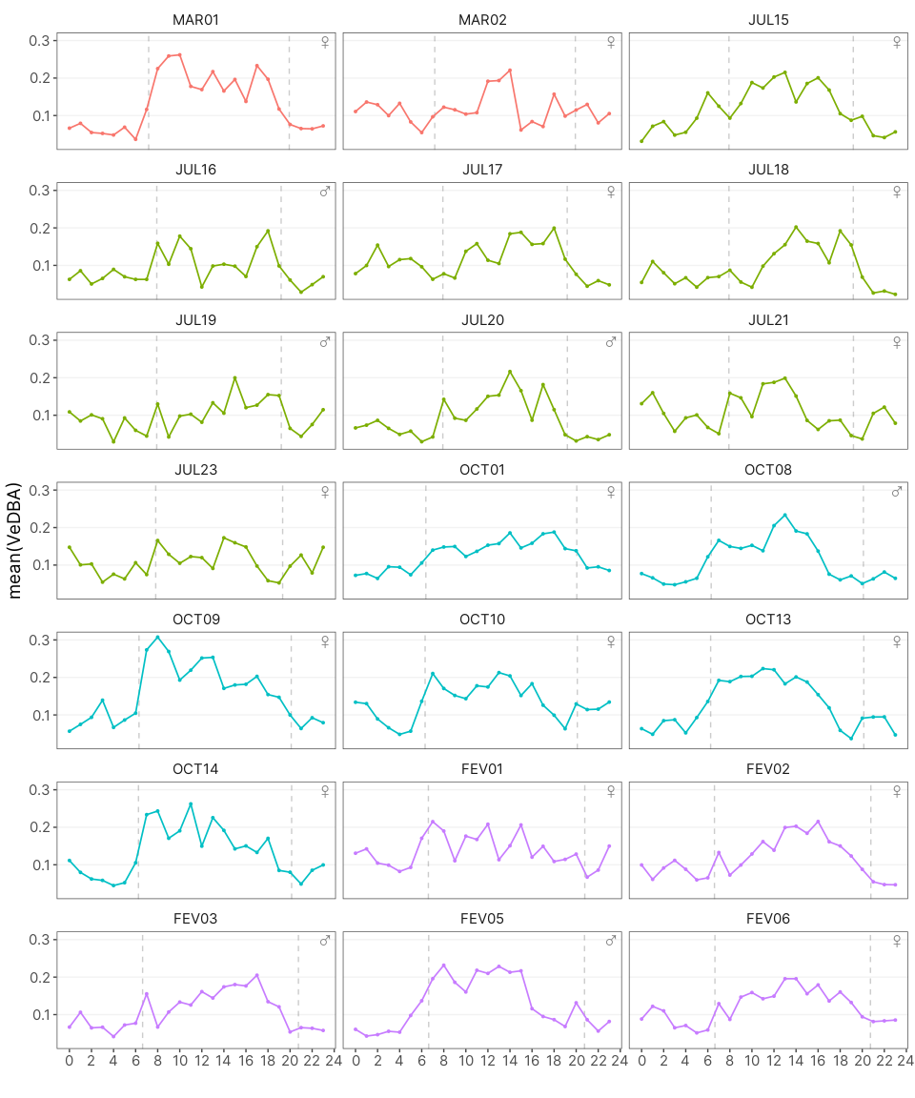

## 6.6 Gráficos Agrupados por Estação e Sexo

### 6.6.1 Histogramas/Gráfico de Densidade

Visualmente parece haver alguma diferença sazonal nas atividade dos tucos. Vamos inspecionar melhor isso agrupando os dados por estação e sexo.

Como o número de amostras varia entre estações e sexo o histograma não seria muito informativo nesse caso. Então pra isso podemos fazer um gráfico de densidade. Esses gráficos basicamente refletem a forma do histograma mas, nesse caso, tem a vantagem de que são padronizados para que a área abaixo da curva serja sempre igual a 1.

Assim, podemos ver como o perfil das distribuições muda ao longo das estações e entre sexos mesmo tendo um número de amostras diferente para cada condição. Os valores em y não significam muita coisa individualmente.

Visualmente temos o que também vimos nos histogramas anteriores. A distribuição parece mudar ao longo do ano. No entanto, quando sobrepomos as distribuições de cada sexo parece não haver muita diferença entre machos e fêmeas.

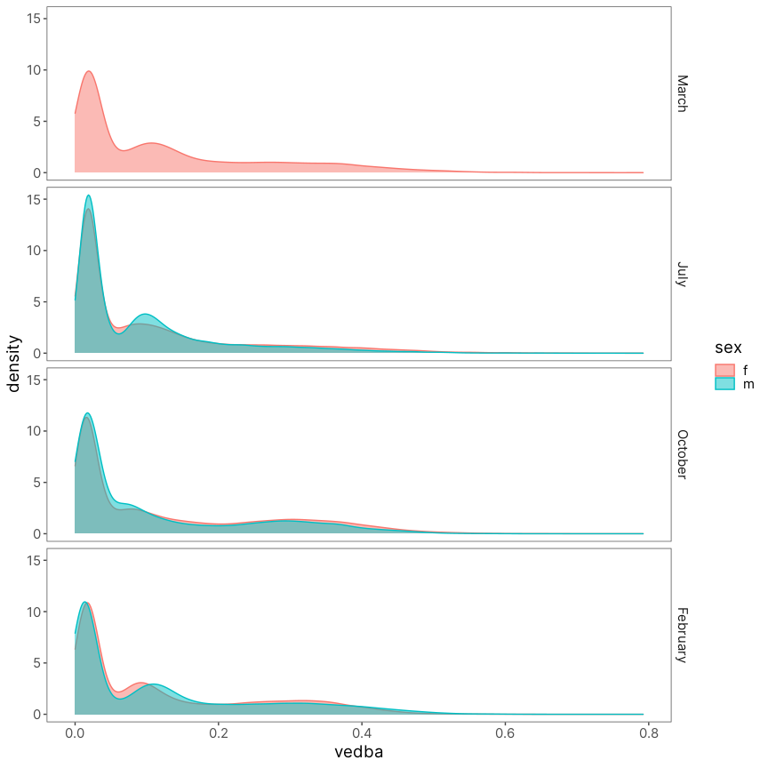

### 6.6.2 Medianas e Boxplots

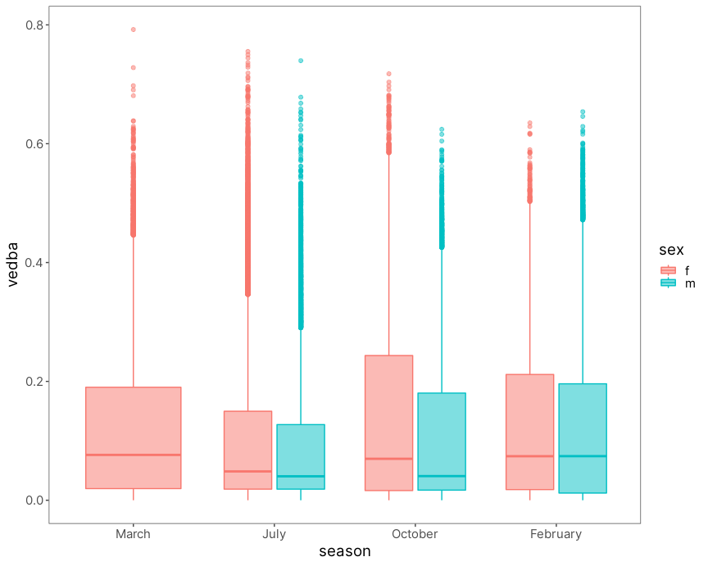

## 6.7 ECDF

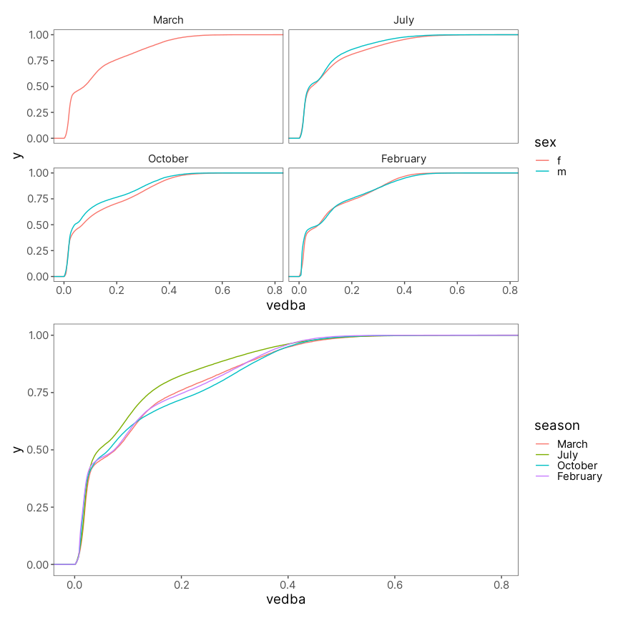

## 6.8 Padrão Médio de Atividade por Estação e Sexo

Nesse último gráfico eu queria verificar se temporalmente existe alguma diferença entre macho e fêmeas. Cada painel é um grupo entre as opções de combinação de sexo e estação.

As mesma curvas de VeDBA médio por hora são mostradas em cinza ao fundo, onde cada curva representa um animal diferente. Em cores, colorido por estação, está a média de VeDBA por hora do grupo representado no painel.

Aparentemente também não existe uma diferença tão grande entre machos e fêmeas quanto aos horário de atividade. Porém, temos um n bem baixo de machos capturados o que torna dificil fazermos uma observação muito concreta.

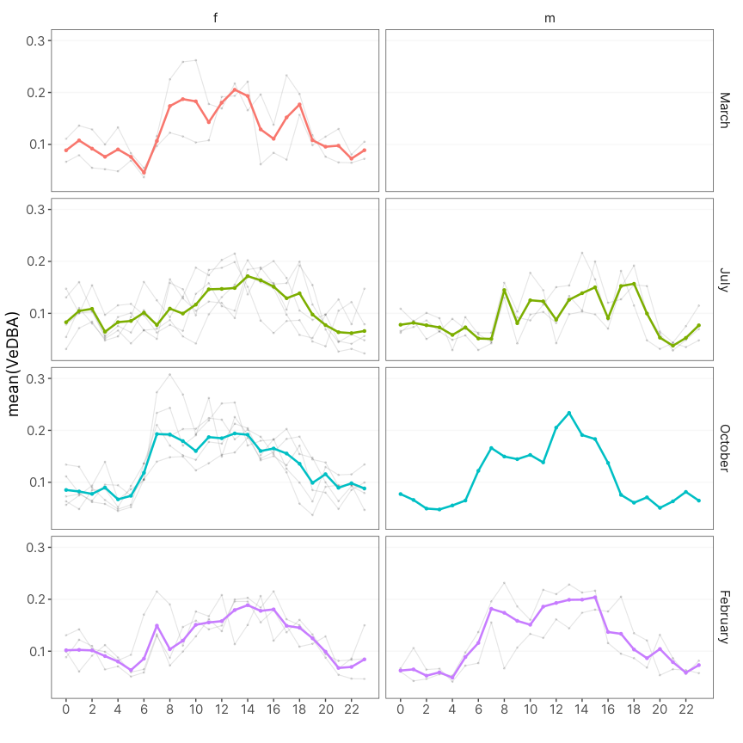

# References

Abraham, E., H.F. del Valle, F. Roig, L. Torres, J.O. Ares, F. Coronato, and R. Godagnone. 2009. “Overview of the Geography of the Monte Desert Biome (Argentina).” *Journal of Arid Environments* 73 (2): 144–53. <https://doi.org/10.1016/j.jaridenv.2008.09.028>.

Amaya, Juan Pablo, Juan I. Areta, Veronica S. Valentinuzzi, and Emmanuel Zufiaurre. 2016. “Form and Function of Long-Range Vocalizations in a Neotropical Fossorial Rodent: The Anillaco Tuco-Tuco ( *Ctenomys* Sp.).” *PeerJ* 4 (October): e2559. <https://doi.org/10.7717/peerj.2559>.

Aranda-Rickert, Adriana, and Sebastián Fracchia. 2011. “Pogonomyrmexcunicularius as the Keystone Disperser of Elaiosome-Bearing Jatropha Excisa Seeds in Semi-Arid Argentina: Pogonomyrmex Cunicularius Ants as Keystone Seed Dispersers.” *Entomologia Experimentalis Et Applicata* 139 (2): 91–102. <https://doi.org/10.1111/j.1570-7458.2011.01111.x>.

Bivand, Roger, and Nicholas Lewin-Koh. 2020. “Maptools: Tools for Handling Spatial Objects.” <https://CRAN.R-project.org/package=maptools>.

Burnham, Kenneth P., David Raymond Anderson, and Kenneth P. Burnham. 2002. *Model Selection and Multimodel Inference: A Practical Information-Theoretic Approach*. 2nd ed. New York: Springer.

Fracchia, S., L. Krapovickas, A. Aranda-Rickert, and V.S. Valentinuzzi. 2011. “Dispersal of Arbuscular Mycorrhizal Fungi and Dark Septate Endophytes by Ctenomys Cf. Knighti (Rodentia) in the Northern Monte Desert of Argentina.” *Journal of Arid Environments* 75 (11): 1016–23. <https://doi.org/10.1016/j.jaridenv.2011.04.034>.

Jannetti, Milene G., C. Loren Buck, Veronica S. Valentinuzzi, and Gisele A. Oda. 2019. “Day and Night in the Subterranean: Measuring Daily Activity Patterns of Subterranean Rodents (Ctenomys Aff. Knighti) Using Bio-Logging.” *Conservation Physiology* 7 (1). <https://doi.org/10.1093/conphys/coz044>.

Langrock, Roland, Ruth King, Jason Matthiopoulos, Len Thomas, Daniel Fortin, and Juan M. Morales. 2012. “Flexible and Practical Modeling of Animal Telemetry Data: Hidden Markov Models and Extensions.” *Ecology* 93 (11): 2336–42. <https://doi.org/10.1890/11-2241.1>.

Leos-Barajas, Vianey, Theoni Photopoulou, Roland Langrock, Toby A. Patterson, Yuuki Y. Watanabe, Megan Murgatroyd, and Yannis P. Papastamatiou. 2017. “Analysis of Animal Accelerometer Data Using Hidden Markov Models.” Edited by Robert B. O’Hara. *Methods in Ecology and Evolution* 8 (2): 161–73. <https://doi.org/10.1111/2041-210X.12657>.

McClintock, Brett T., Roland Langrock, Olivier Gimenez, Emmanuelle Cam, David L. Borchers, Richard Glennie, and Toby A. Patterson. 2020. “Uncovering Ecological State Dynamics with Hidden Markov Models.” Edited by Tim Coulson. *Ecology Letters* 23 (12): 1878–1903. <https://doi.org/10.1111/ele.13610>.

McClintock, Brett T, and Theo Michelot. 2021. “momentuHMM: R Package for Analysis of Telemetry Data Using Generalized Multivariate Hidden Markov Models of Animal Movement,” 155.

Michelot, Theo, and Roland Langrock. 2019. “A Short Guide to Choosing Initial Parameter Values for the Estimation in moveHMM,” 10.

Papastamatiou, Yannis P., Yuuki Y. Watanabe, Urška Demšar, Vianey Leos-Barajas, Darcy Bradley, Roland Langrock, Kevin Weng, Christopher G. Lowe, Alan M. Friedlander, and Jennifer E. Caselle. 2018. “Activity Seascapes Highlight Central Place Foraging Strategies in Marine Predators That Never Stop Swimming.” *Movement Ecology* 6 (1): 9. <https://doi.org/10.1186/s40462-018-0127-3>.

Patterson, Toby A., Marinelle Basson, Mark V. Bravington, and John S. Gunn. 2009. “Classifying Movement Behaviour in Relation to Environmental Conditions Using Hidden Markov Models.” *Journal of Animal Ecology* 78 (6): 1113–23. <https://doi.org/10.1111/j.1365-2656.2009.01583.x>.

Pohle, Jennifer, Roland Langrock, Floris M. van Beest, and Niels Martin Schmidt. 2017. “Selecting the Number of States in Hidden Markov Models: Pragmatic Solutions Illustrated Using Animal Movement.” *Journal of Agricultural, Biological and Environmental Statistics* 22 (3): 270–93. <https://doi.org/10.1007/s13253-017-0283-8>.

Qasem, Lama, Antonia Cardew, Alexis Wilson, Iwan Griffiths, Lewis G. Halsey, Emily L. C. Shepard, Adrian C. Gleiss, and Rory Wilson. 2012. “Tri-Axial Dynamic Acceleration as a Proxy for Animal Energy Expenditure; Should We Be Summing Values or Calculating the Vector?” *PLOS ONE* 7 (2): e31187. <https://doi.org/10.1371/journal.pone.0031187>.

R Core Team. 2020. “R: A Language and Environment for Statistical Computing.” [https://www.R-project.org/.](https://www.R-project.org/)

Shepard, Elc, Rp Wilson, Lg Halsey, F Quintana, A Gómez Laich, Ac Gleiss, N Liebsch, Ae Myers, and B Norman. 2008. “Derivation of Body Motion via Appropriate Smoothing of Acceleration Data.” *Aquatic Biology* 4 (December): 235–41. <https://doi.org/10.3354/ab00104>.

Tomotani, Barbara M., Danilo E. F. L. Flores, Patrícia Tachinardi, José D. Paliza, Gisele A. Oda, and Verônica S. Valentinuzzi. 2012. “Field and Laboratory Studies Provide Insights into the Meaning of Day-Time Activity in a Subterranean Rodent (Ctenomys Aff. Knighti), the Tuco-Tuco.” Edited by Ralph E. Mistlberger. *PLoS ONE* 7 (5): e37918. <https://doi.org/10.1371/journal.pone.0037918>.

Valentinuzzi, Verónica Sandra, Gisele Akemi Oda, John Fontenele Araújo, and Martin Roland Ralph. 2009. “Circadian Pattern of Wheel-Running Activity of a South American Subterranean Rodent ( *Ctenomys Cf Knightii* ).” *Chronobiology International* 26 (1): 14–27. <https://doi.org/10.1080/07420520802686331>.

van de Kerk, Madelon, David P. Onorato, Marc A. Criffield, Benjamin M. Bolker, Ben C. Augustine, Scott A. McKinley, and Madan K. Oli. 2015. “Hidden Semi-Markov Models Reveal Multiphasic Movement of the Endangered Florida Panther.” Edited by Tim Coulson. *Journal of Animal Ecology* 84 (2): 576–85. <https://doi.org/10.1111/1365-2656.12290>.

Williams, Cory T., Kathryn Wilsterman, Amanda D. Kelley, André R. Breton, Herbert Stark, Murray M. Humphries, Andrew G. McAdam, Brian M. Barnes, Stan Boutin, and C. Loren Buck. 2014. “Light Loggers Reveal Weather-Driven Changes in the Daily Activity Patterns of Arboreal and Semifossorial Rodents.” *Journal of Mammalogy* 95 (6): 1230–39. <https://doi.org/10.1644/14-MAMM-A-062>.

Zucchini, Walter, Iain MacDonald, and Roland Langrock. 2016. *Hidden Markov Models for Time Series - An Introduction Using R*. Vol. 43.